Native Wellness Garden
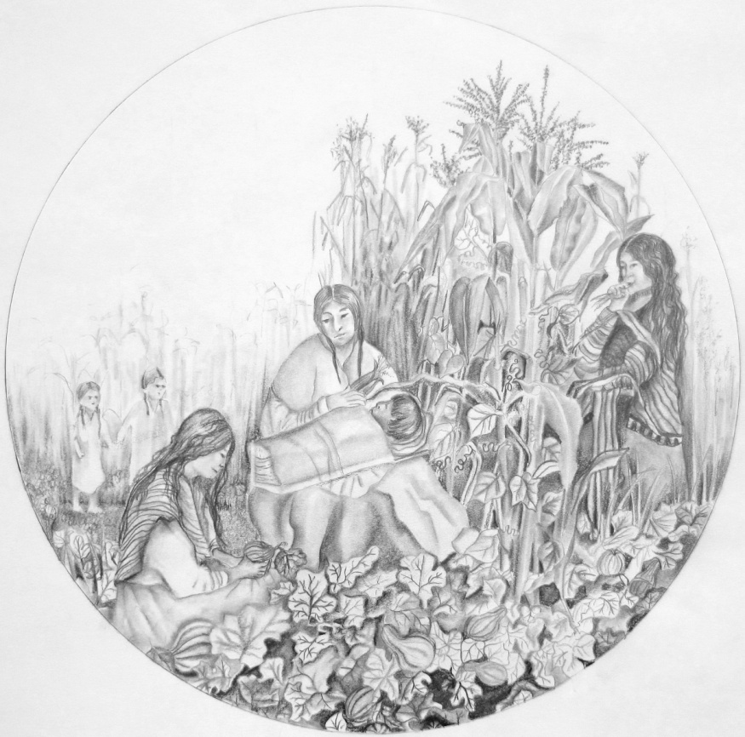

Please join us for a special event:
Three Sisters
Ceremony
Tuesday, June 11th 4-6pm
In the Garden

Featuring:

Stories, Teachings, Planting,
Art & More!

The Native Wellness Garden is located at:
125 W Saveland Ave, Milwaukee
in the Tippecanoe Presbyterian Church’s Community Garden
(4 blocks South of Holt & 1 block West of Howell, near the MCTS’s GREEN line bus)

Contact Jennifer to get involved or for more info:
414-383-9526 x 157 Jcasey@gliihc.net

About the Native Wellness Garden Project:
The goal of the Gerald Ignace Indian Health Center’s
@Native Urban Gardens

Diabetes Program Garden Project is to support the health, peace, and welfare of Milwaukee’s American Indian community through collaborating with Native and non-native organizations and individuals to foster garden health promotion and disease prevention activities.

