Living Waters Contemplative Life Center Invites YOU to……

An Alternative To Friday Night Out….
“Blues” Around the Labyrinth!

Friday Night July 12th
6:30-10pm

With..
ElectiViolet

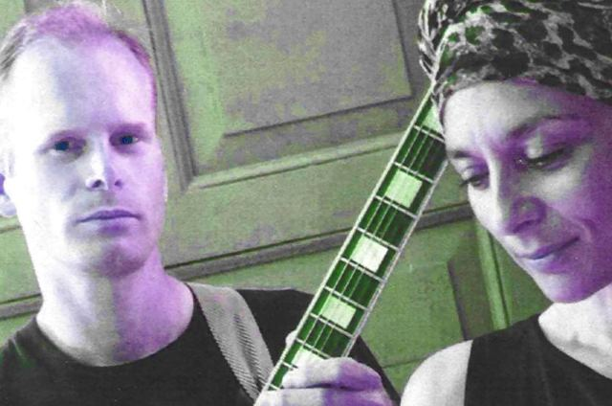

Experience Walking the Labyrinth…an ancient holy ritual!
Enjoy the Music….Dance and Play!
Be Community!

-Rain or Shine-
…for we have an inside labyrinth as well!
Bring a lawn chair!
Brats and Beverages For Purchase.
Fire Pit and S’mores for ALL to enjoy!
Family Friendly! Open to All!

Tippecanoe Church
125 W. Saveland Avenue
BayView Area of Milwaukee

September 13th: Celtic music around the labyrinth!
With Christopher’s Legacy

Send to Julia, Emily, Tom for neighborhood

